# Aycada Simulation Game for Production and Capacity Management

## Examination: Decision Paper of the Product Manager

Name: Jana

Surname: Kalthoff

Group (D1, D2, D3 or BWL/Block): E1

Companies (C1, C2, ... C11): C7

## Situation

The Executive Board makes monthly decisions on

* The planned production volumes for the four products offered by the company [PU/month] and
* The planned production capacity for the four production stages [hours/month].

Each month, the Executive Board as a body must therefore make eight individual decisions. The first decision is made for month 36.

Each board member has the task of creating a decision template, which serves in particular to support the first joint board decision for month 36. This paper answers the following questions:

## Questions

### Is it economically advantageous to offer the product? (2 points)

**Yes, it is economically advantageous because firstly, if we deduct the full total costs per PU (5.05 EUR) from the sales price per PU (6.08 EUR), we are still making a profit of 1.03 EUR per PU meaning a profit margin of 16.9% of the price per PU. So the sales price is higher than full costs.**

**Besides that, we have a contribution margin of 5.14 EUR per PU in month 36 of product 1. That means that these 5.14 EUR per PU can be used to cover a part of the fixed costs of the company.**

**The cumulated contribution margin at the end of month 36 is 32,855,496 EUR, and specifically in month 36, the contribution margin is 1,003,325 EUR, which means that we can use these 1,003,325 EUR in month 36 to cover a part of the fixed costs of the monthly company cost. That supports the fact that the product is economically advantageous to offer.**

**Another aspect we can look at is the tradeoff between Inventory and Backlogging Costs: As we can see from the data provided to us, the costs for inventory holding is 0.15 EUR per PU while the backlogging costs are 0.28 EUR per PU which means that we should keep producing in order to avoid backlogging costs and therefore “save” money.**

### Are there time-dependent patterns in past demand (measured in packaging units of the product)? (2 points)

**Yes, there are some time-dependant patterns in past demand. Looking at the overall Market demand of Product 1, we can see that there are peaks and troughs every 12 months. For example, we have a trough of 1,801,096 PU/month in month 7, and peaks of 2,155,252 in month 13 and 2,192,916 PU/month in month 14, around 6 months later. 6 months later again, in month 19 and 20 we have a trough again and another 6 months later a peak again in month 26. We can see that there is clearly some seasonal cycle in past demand.**

**Overall, we can see that the incoming orders (meaning demand) are staying in a range of around 1,775,000 to 2,210,000 PU/month though with the a few fluctuations. But overall, the demand stays in this range and therefore relatively stable over the past 36 months.**

**If you take a look at the incoming orders of product 1 of our company, we can see the exact same trend as for overall market demand of product 1. The demand stays stable in a range between 164,000 and 200,000 PU/month of incoming orders, again with e.g a trough in month 20 and a peak in month 26. That clearly tell us that there is a seasonal cycle, not only for overall market demand of product 1 in past demand, but also for demand of product 1 of our company which later is important for our forecasting technique.**

Which forecasting technique is best suited to provide the most accurate prediction of demand for the product? (2 points)

**The exponential and seasonal forecasting method is best suited as a forecasting method. It is the function “forecast.ets” in excel. We use this method because it represents the past data the most accurate as past data follows a rather fluctuating trend with a seasonal cycle (as explained in the exercise above) and the exponential and seasonal forecast does that as well. The linear forecasting method rather shows a linear trend/line which means that incoming orders rather stay stable which is not the truth in the past, so would not be very accurate. As you can see on the graph when using the exponential and seasonal forecasting method, the forecasted numbers show a seasonal cycle of peaks and troughs every 12 months as well, which tells us that it is very much likely to be accurate.**

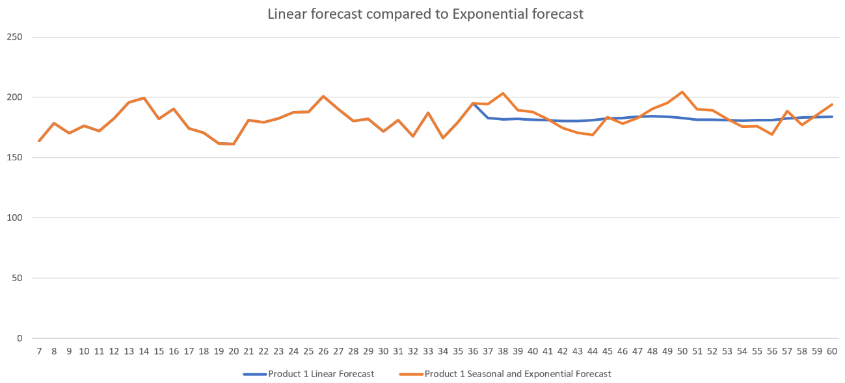

### How high will the demand be in the month (measured in packing units) in which the production quantity to be determined now is available to be delivered? (Note: To answer this question, use the forecast technique recommended above.) (3 points)

**Because of the three month delay between the decision on Planned Production Quantity and Desired Deliveries, we have to look at our forecasted numbers for month 39 (36+3months).  
As we can see from our exponential and seasonal forecasting model, the demand in month 39 is 189,507 units.**

Ein Bild, das Tisch enthält.

### What is the mean absolute deviation between the actual observed demand for the product and the forecast (both measured in packing units) for months 25 to 36 when the selected forecasting technique is applied? (2 points)

**First, we used our forecasting method from above for forecasting months 25 to 26 but based on the months before from 7 to 24. Then, I took the absolute difference between the actual observed demand and the forecasted ones for month 25 to 36.   
After that, I took the average of all differences to get the mean absolute deviation which was 8,481. That is the mean absolute deviation between the actual observed demand and the forecast for months 25 to 36.**

### What quantity of the product (measured in packing units) would you keep in inventory? (2 points)

**At month 36, there is 348,354 in inventory. I would keep all of these sell them to the customers. Starting month 36, I would start producing according to the demand forecast & keep 10,540 always in inventory as a backup for deviation from the forecast or unforeseen issues like a machine breaking down. The number 10,540 is the standard deviation for all the demands from months 1-60 and represents the average changes that occur on a monthly basis.**

### 

**Released prod quantity = 178k**

**Inventory 348k**

**So keep around 250k in inventory to be able to cover a bit more than a month of prod quantities if we cant fill the orders sometime???**

### What planned production quantity of the product you are responsible for do you propose for month 36? (1 point)

**Around 180k right now, want to decrease inventory a bit, so plan 100k for this month to fill the other incoming orders w inventory**

**Planned prod quan and delivery takes 3 months, so decr quan now and maybe 20k the next 2 months, so 3 months in total were you decr inventory and it will start decreasing 3 months later until month 6**

**I would produce according to demand + the standard deviation of 10,540. 205605.1006??**

### What quantity of the product (measured in packing units) will be in the production and quality control process (WIP – work in process) in month 37?

### **Need to look how high released quan was 2 months before bc WIP invenotry takes 2 month, so month 35???????????**

**Released prod quan in month 35: 180,671 (oder multiply by 2??)**

**Oder:**

**Have to take month 36 and 35**

**36 prod quan is in quarantine, and 35 is in production**

**Have to look at released quan jeweils von beiden monaten von 2 monaten davor**

**Also:**

**Month 33 released prod quan: 181,697**

**Month 34 released prod quan: 179,387**

**Sum: 361,084**

**Oder:**

**Look at graph WIP Inventory: ???????????????**

(1 point)

## Evaluation criteria

|  |  |  |  |
| --- | --- | --- | --- |
|  | Insufficient | Satisfactory | Very good |
| Correctness of the answer | Answer is grossly incorrect | Answer is partially incorrect | Answer is correct |
| Justification of the answer | No justification available, neither in text form nor as a calculation | Satisfactory justification | Clear and convincing justification of the answer, with calculation (if applicable) |
| Correctness of the data/information used | Incorrect data/information used | Partly correct, partly incorrect data/information used | Correct and appropriate data/information used |